**A WEIGHT BASED PERSONALIZED RECOMMENDATION USING IDIOCENTRIC AND COLLABORATIVE FILTERING**

**SYSTEM DESIGN**

**ALGORITHMIC FLOW:**

Component Diagram:

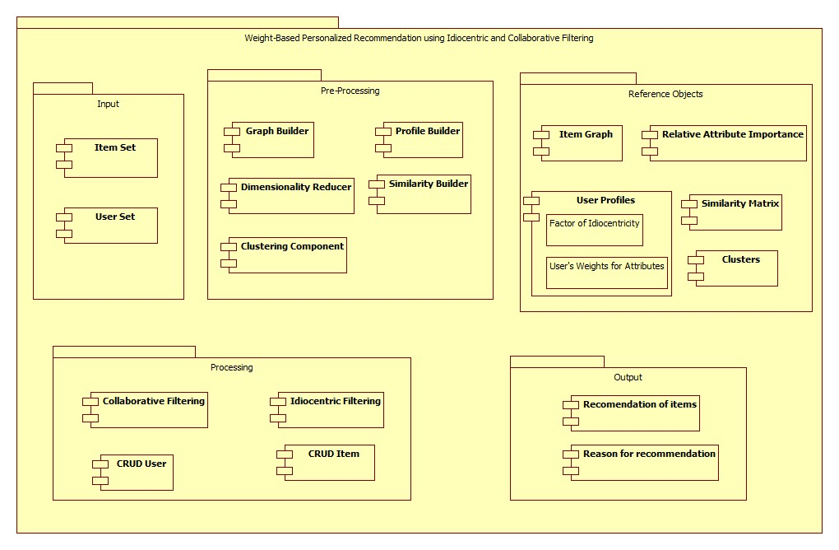

* The above component diagram shows different components of our recommendation system. There are four different components, viz. Input, Pre processing, Processing and Output. The details of each component are as shown in the above figure.

Activity Diagram:

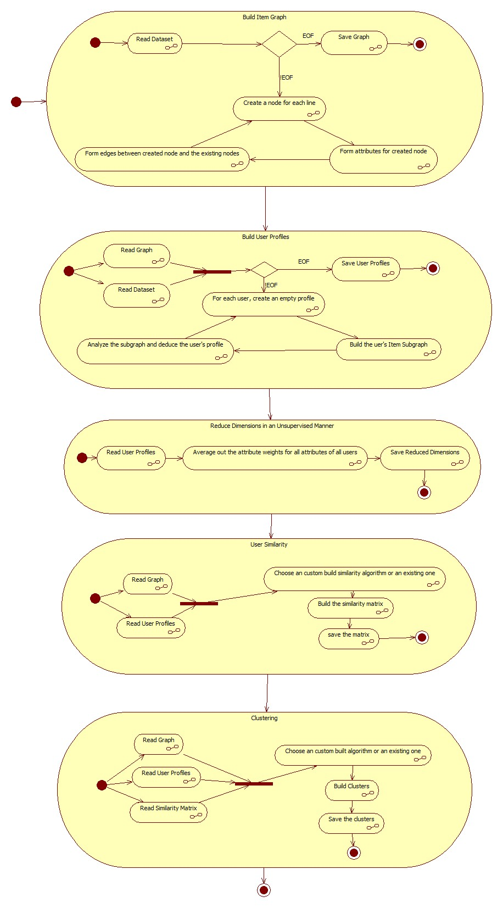

Algorithm:

1. Build Item graph:

* Item graph is built by reading the dataset and forming a graph data-structure that represents the relation between items. The attributes of items are mapped onto the attributes of the nodes.

1. Build User Profiles:

* In this step, user profiles are built by recognizing the relationship between users, the items they have consumed and the item graph. For each user, a set of properties are deduced that convey the orientation of the user and the relative attributive importance. The orientation of the user denotes the extent to which the user is idiocentric.

1. Reduction of Dimensionality in an unsupervised manner:

* The user’s parameters include orientation of the user and the relative importance of attributes to the user. The item parameter includes the relative importance of the each attribute. These parameters can be used to perform dimensionality reduction of the attribute set for the items. Dimensionality Reduction for the item dataset is brought about by using the weight vector of each user and thus eliminating the redundant attributes in the item dataset by considering their average.

1. User Similarity:

* In order to perform collaborative ﬁltering, we need to compute the similarity between all pairs of users. The algorithm that we intend to develop is a variation of Jaccard’s Similarity, by taking a sub graph of items common to users.

1. Clustering:

* By considering the User similarity matrix and reading the user profiles along with the item graph, we build a cluster of users by choosing a custom built algorithm or an existing one. There may be overlapping clusters as a user can be a part of many clusters.

**UI MOCKUP**:

1. Start Up page:

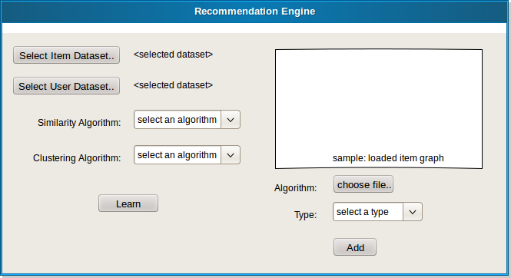

1. Processing Page:

